|  |
| --- |
| IMPORTING TABLES TO COBALT |

With the code generator set up and the database ready, the next step is to import these tables for Cobalt to recognize.

**SETUP A DATABASE CONNECTION**

Back on the code generator, select the “Database Connections” option and then “Create New Connection”.

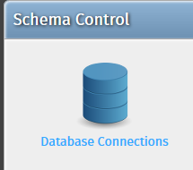

Enter the connection parameters for connecting to the database that we created earlier:

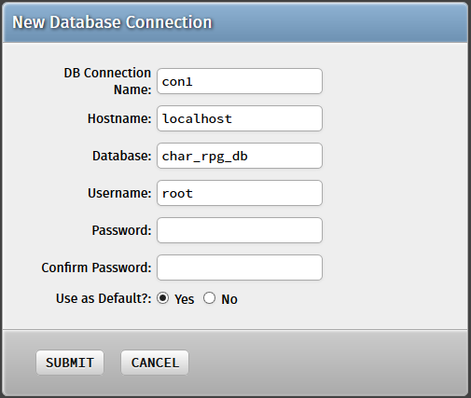

Once successful, you may proceed to “Import Tables”, which will process the tables from our database and add them to the code generator.

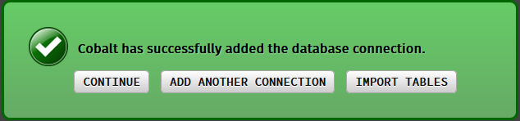

**IMPORTING TABLES**

Aside from reaching it after successfully setting up the database connection, you may also click on the “Tables” option to begin importing your database tables. From there, select “Import Tables” for the import process to begin.

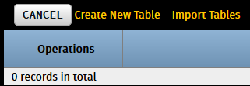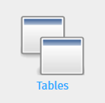

At the Import Tables menu, make sure all the tables imported are checked so that Cobalt will process them. We will put them all under one folder – character – which we shall put in the “Folder / Subdirectory” option. This is to ensure that their associated CRUD files are all in one place later on.

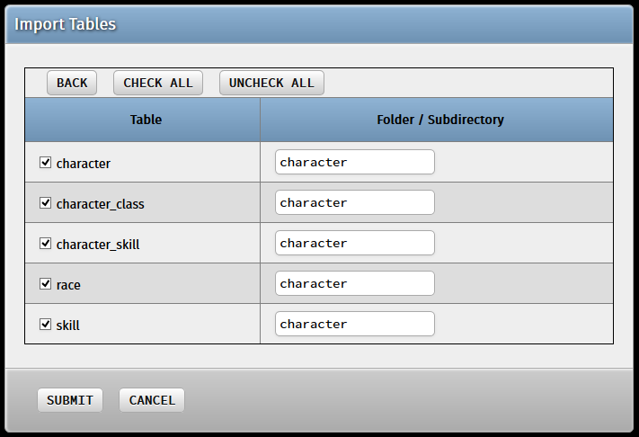

Hit “Submit” and you will be notified if the table import is successful.

